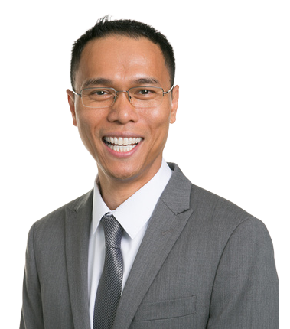
Louiery R Sincioco (Sin)
Software Architect and Technical Lead
louiery@gmail.com / sincioco.com
+63 (966) 230-4023

Software engineering leader with 30+ years building enterprise applications across commercial, financial and defense environments. Hands-on in C#/.NET, Azure and modern web development, with recent delivery of a cybersecurity SaaS platform and ChatGPT-powered threat queries.
30+ 20 8+
Years in Software Engineering Professional Certifications Years in iOS and Mobile Web

Industry and Product Experience
1994–2026 • Bars show role dates; experience categories can overlap.
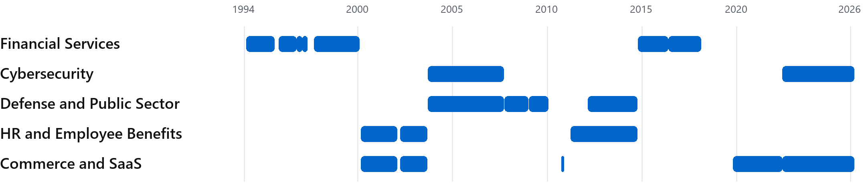
Financial Services: RCM Capital Management, Sumitomo Bank, Charles Schwab and Alpha Theory.
Cybersecurity: Marine Corps firewall and network security work; Data Defenders threat monitoring.

Five Areas of Expertise
01 C# and .NET Engineering
ASP.NET Core, REST APIs and enterprise applications
02 Azure and AI Integration
Azure Functions, Logic Apps, Azure SQL, SaaS and ChatGPT
03 Web and Mobile Experiences
Angular, Blazor, JavaScript, HTML/CSS, Swift and Objective-C
04 Data and Application Security
SQL Server, stored procedures, authentication and encryption
05 Technical Leadership
Architecture, mentoring, Agile/Scrum and full lifecycle delivery
Experience

Enterprise Software and Product Delivery

Data Defenders Jun 2022 – Mar 2026
Architect / Technical Lead / Senior Developer | United States and Philippines
• Designed and deployed an Azure serverless cybersecurity platform for the City of Aurora and other clients, giving analysts real-time threat dashboards.
• Led and mentored engineers in Metro Manila and converted the product into a software-as-a-service offering.
• Integrated ChatGPT so analysts could query threat data in natural language; provided on-call application support.
Azure Functions • Logic Apps • Azure SQL • ASP.NET Core • Angular • Blazor

Web Partner Group Oct 2019 – Jun 2022
Architect / Senior Developer | United States and Philippines
• Modernized internal applications supporting product sales through Amazon, eBay and Walmart.
• Built with ASP.NET Core, Blazor, Angular and SQL Server to equip teams with tools for online retail operations.
ASP.NET Core • Blazor • Angular • SQL Server • Git

Alpha Theory May 2016 – Feb 2018
Senior Front-End Developer | Charlotte, North Carolina
• Served as front-end UI architect and technical lead for modernization of the financial technology company’s core product.
• Partnered with the CTO and VP of User Interface to move the product to a component-based Angular interface.
Angular • AngularJS • JavaScript • HTML5 • CSS3 • D3.js

Charles Schwab Oct 2014 – May 2016
Senior Technology Staff / Technical Lead / Scrum Master | Englewood, Colorado
• Led iOS, ASP.NET MVC and SharePoint projects for an investment management business with more than $260B in assets under management at the time.
• Built an enterprise iOS business-continuity app with secure authentication, encryption, caching and REST APIs; owned design, implementation, testing and documentation.
• Integrated MobileIron for per-app VPN, policy delivery, data protection and remote management.
Swift • Objective-C • iOS • ASP.NET MVC • Web API • SQL Server • SharePoint
Joined through Randstad as Senior iOS Developer, Oct 2014–Feb 2015; direct role, Feb 2015–May 2016.

ITT Exelis Feb 2012 – Oct 2014
SharePoint Architect / Developer | Colorado Springs, Colorado
• Architected and developed XCAMS to track personnel in the Middle East using SharePoint and WCF services.
Concurrent part-time engagement
Experience and Credentials

Engineering Foundations and Credentials

Towers Watson Mar 2011 – Oct 2014
Senior SharePoint Developer / Acting Architect | Denver, Colorado
• Migrated SharePoint applications and data and developed custom portals for major enterprise clients, including Foot Locker, HCA, HSBC and American Express.
• Delivered visual web parts, page layouts and WCF services, alongside native iOS and responsive web applications.
Other Architecture Engagements
2010–2011 Insight Global, Demand Foresight and 3t Systems — SharePoint architecture, business intelligence, manufacturing systems and developer mentoring.

Microsoft Jan 2009 – Jan 2010
Premier Field Engineer / Application Developer Consultant. Supported U.S. Air Force SharePoint systems and .NET development for the Missile Defense Agency, DSCA and Joint Warfare Analysis Center.

ITT Sep 2007 – Dec 2008
Programmer / Database Subject Matter Expert. Architected a U.S. Army logistics web application used in Iraq, Kuwait, Afghanistan and Qatar.

United States Marine Corps Sep 2003 – Sep 2007
Sergeant E-5 / Developer / Network and Security Administrator. Built mission-essential applications and served as chief firewall administrator in Al Asad, Iraq.
Early Financial and Platform Experience
RCM Capital Management — Feb 1994–Aug 1995 and Nov 1995–Oct 1996. Developed enterprise applications and supported the full software development lifecycle.
Sumitomo Bank of California — Oct 1996–Jan 1997. Built an Exchange groupware application with database access, serial routing and multilevel approvals.
Charles Schwab — Jan–May 1997 and Sep 1997–Jan 2000. Developed brokerage reporting and internal audit applications covering schedules, risk and business processes.
WageWorks — Mar 2000–Jan 2002 and Apr 2002–Aug 2003. Architected employer-facing e-commerce and SaaS applications; established coding standards and mentored developers.
Other Early Experience: Oracle and Lante (1995–1997).

Certifications and Recognition
Azure AI Engineer (AI-102) • Azure Fundamentals (AZ-900) • Azure AI Fundamentals (AI-900) • Azure Data Fundamentals (DP-900) • Certified Scrum Master • Microsoft Certified Professional Developer (MCPD)
View Microsoft Certification Transcript
Microsoft Great People Great Performance Award (2009) • ITT Silver Team Award (2008) • Two Navy and Marine Corps Achievement Medals (2005 and 2006)
Education
An undergraduate of Computer Science in San Francisco State University (1993-1997) and took courses that included assembly, C and object-oriented programming in C++.

